Challenge

Please download this dataset, which describes the gene activity level data (24,712 genes) measured for 251 breast cancer patients.
https://xenabrowser.net/datapages/?cohort=Breast%20Cancer%20(Miller%202005)&removeHub=ht tps%3A%2F%2Fxena.treehouse.gi.ucsc.edu%3A443
Examples: 251
Features: 24,712

In the file “Phenotypes”, there are potential output variables to be predicted, e.g. AgeAtDiagnosis, TumorSize, HistologicGrade.
Please apply a set of unsupervised and supervised learning techniques and discuss the results with a brief report (you can use some figures or a PowerPoint presentation, if appropriate, to show the results).

Please be prepared to present your code, and the reasons you chose the approach you did. Demonstrate knowledge of VCS by showing the git log of your work. This can be locally during your presentation or by sending us a link to your Github/Gitlab project

Solution

GitHub repository link: pillliarun79 (github.com) In this repository, it has two files listed below and step by step procedure is written on top on the code
- Miller Breast Cancer Predications (Supervised Machine learning). ipynb
- Cluster.ipynb

1. Miller Breast Cancer Predications (Phenotypes)
As per the give task I have applied supervised machine learning technique for the `Phenotypes` dataset below are the few step which I have taken during the implementation.

Exploratory Data Analysis
- Applying label encoder
- Renaming the columns
- identify the data types like integer, float, and null types
- Visualizing the categorical columns
- Feature Engineering – identify outliers, removing outliers quantile function
- Applying KNN imputer to deal missing values
- Supervised Machine learning models
  - Logistic Regression – accuracy: 53%
  - KNN algorithm – accuracy: 51%
  - SVM– accuracy: 66%
  - Random forest – accuracy: 57%

Output

We have applied Logistic regression, KNN, SVM, Random Forest out of which SVM performs better with 66% accuracy,
Confusion matrix
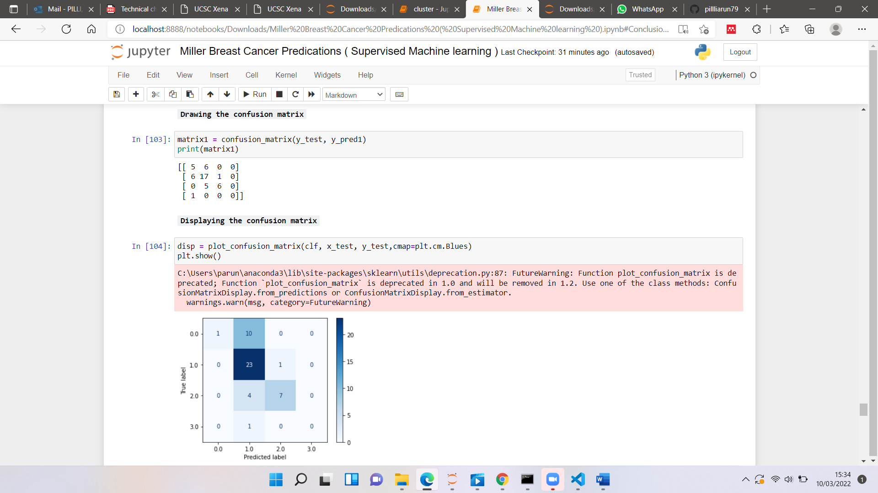

SVM model accuracy

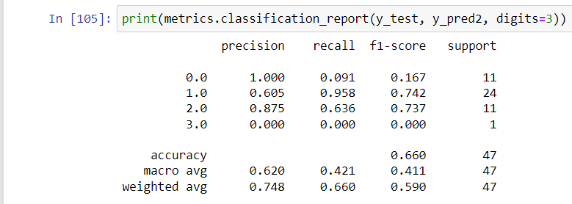

2. Cluster (gene expression)

As per the give task I have applied Unsupervised machine learning technique for the `Gene expression` dataset below are the few steps which I have taken during the implementation,

- Exploratory Data Analysis
- Creating histogram for the given dataset
- Applying label encoder to samples
- Machine Learning Model (K- mean Clustering)

Output:

Elbow method:
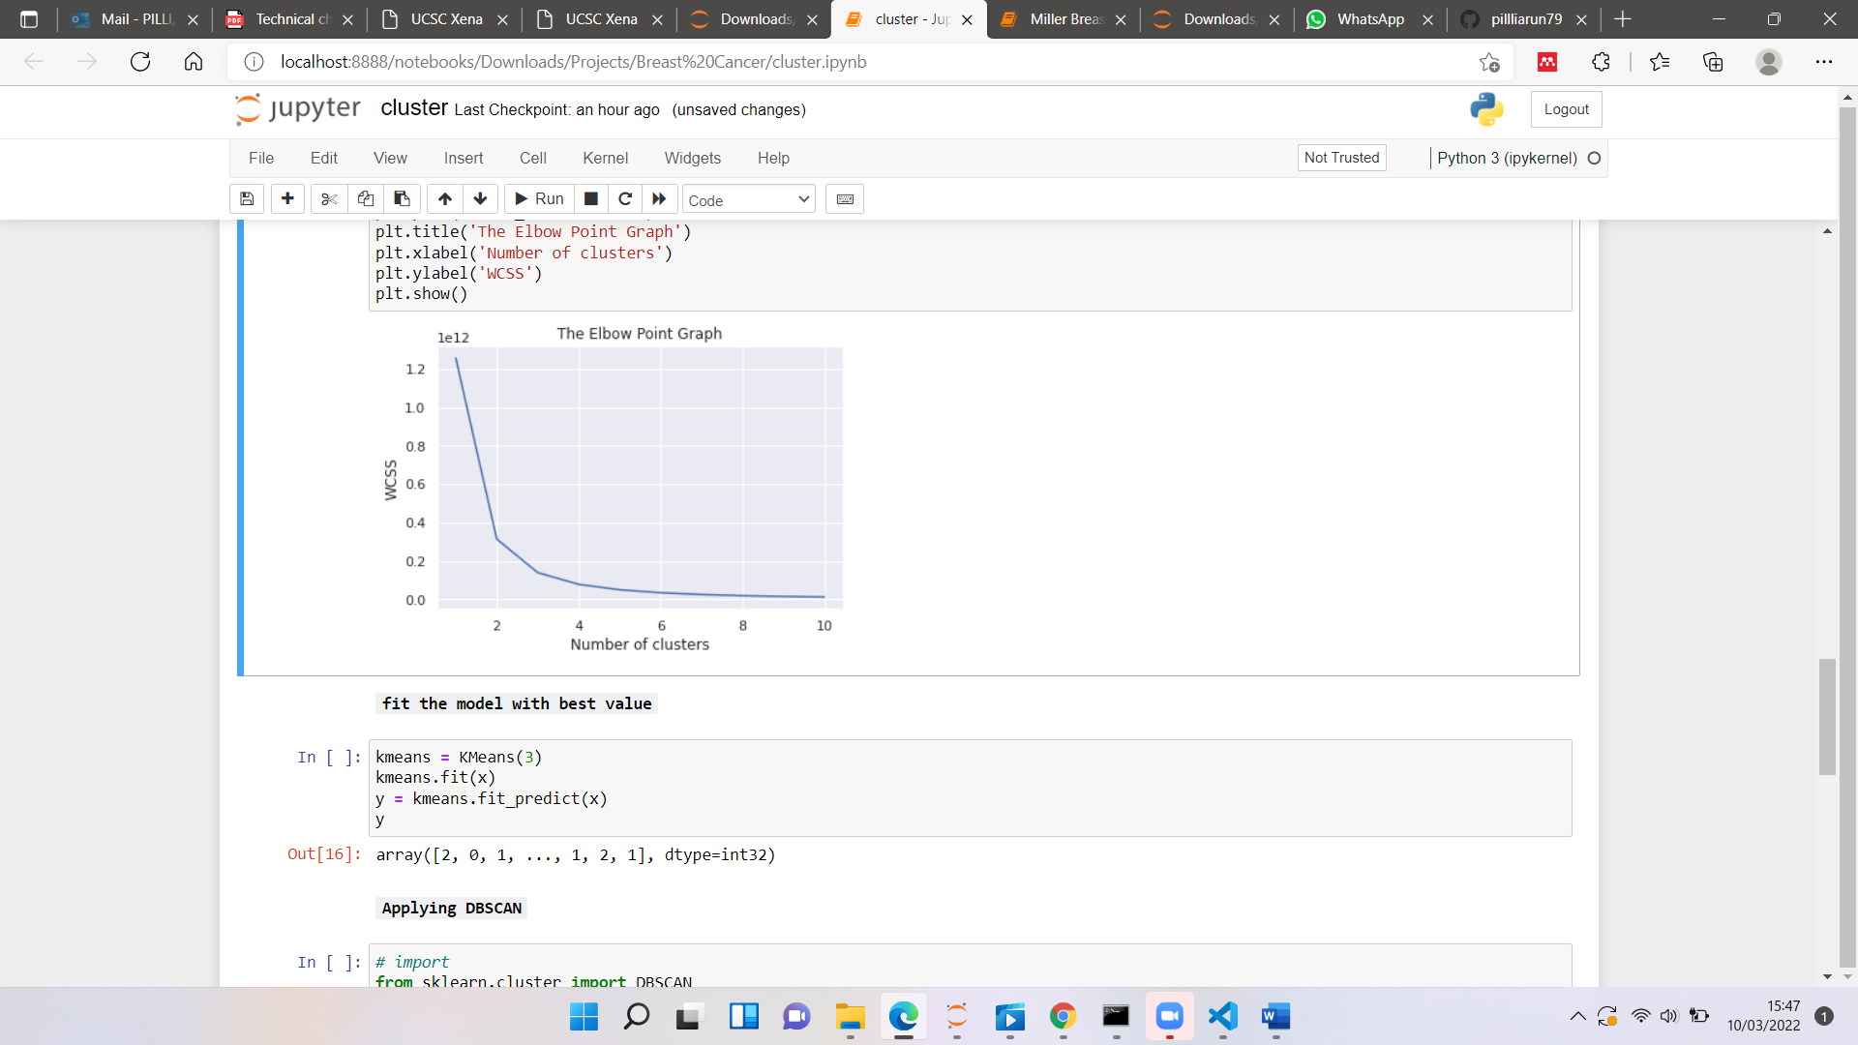

Number of clusters formed
